**Performance Report**

In my analysis, I examined data 32,000 students across15 unique high schools, comprising 8 charter schools and 7 district schools. My focus was on various factors including school type, size, and budget, in order to assess annual performance metrics such as Math Score, Average Reading Score, % Passing Math, % Passing Reading, and % Overall Passing.

Upon analyzing the data, several key findings emerged. Firstly, charter schools consistently demonstrated higher % Overall Passing rates compared to district schools, despite having lower budgets per student.

Additionally, there was a noticeable trend related to school size: **larger schools generally exhibited lower performance than smaller schools.** Notably, **medium-sized** schools stood out with the **best** performance **across multiple metrics**, including Average Math Score, Average Reading Score, % Passing Math, % Passing Reading, and % Overall Passing. Moreover, when comparing charter and district schools, charter schools consistently outperformed district schools across all performance metrics.

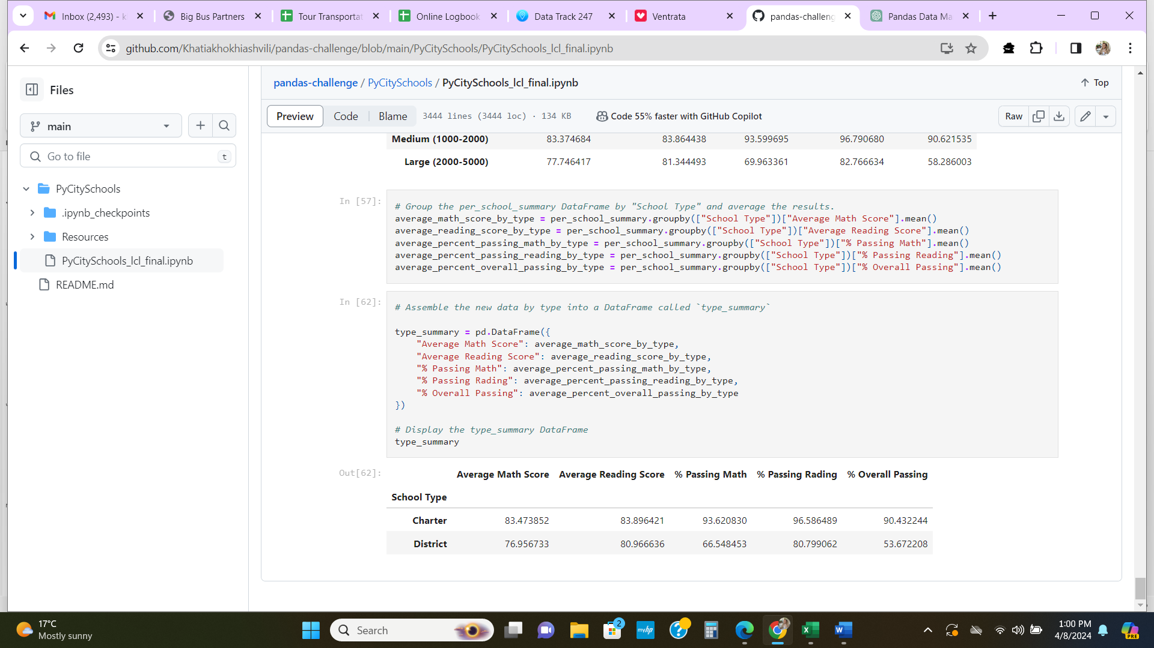

The superior performance of charter schools, despite their lower budgets per student, can be attributed to **their greater autonomy in curriculum development, staffing, budget allocation, and educational practices**. This autonomy enables charter schools to implement innovative and tailored approaches to education, which in turn contributes to their success. By contrast, district schools may be more constrained by bureaucratic processes and regulations, limiting their ability to adapt and innovate.

Further research is needed to explore the specific practices and strategies used by charter schools that contribute to their success. These findings underscore the importance of understanding the factors that drive school performance and may have implications for education policy and practice.